**Business owners direct anger at lawmakers over $15-an-hour wage proposal**

[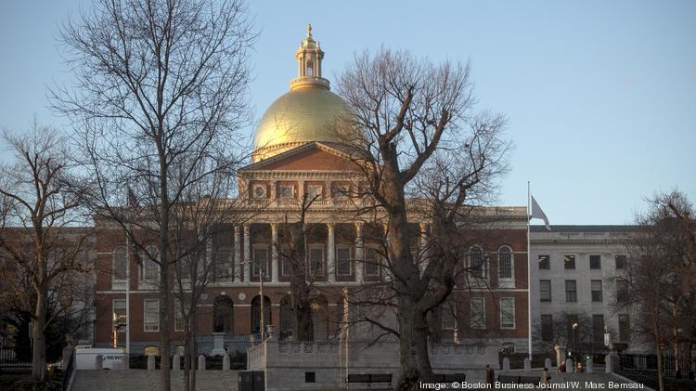](https://www.bizjournals.com/)

Small-business owners went to the State House on Tuesday to express concerns about minimum-wage and other proposals.

W. MARC BERNSAU

By [Greg Ryan](https://www.bizjournals.com/boston/bio/26971/Greg+Ryan)  – Law and Money Reporter, Boston Business Journal

Apr 10, 2018, 3:00pm

At an event at Boston’s Omni Parker House on Tuesday morning, Massachusetts small-business owners got a chance to ask questions of the lawmakers currently negotiating whether their employees will soon have a minimum wage of $15 per hour and months’ worth of paid family and medical leave available to them each year.

One of the first questions, from the owner of a staffing company in Western Massachusetts, was illustrative of the crowd’s general feelings toward the five Labor and Workforce Development Committee members sitting on stage.

“You came in, and you’re smiling. We’re not. We are getting crushed by what you’re doing,” he said to cheers from his fellow audience members.

The local chapter of the [National Federation of Independent Business](http://companies.bizjournals.com/profile/nfib/145245/) and a host of the state’s other business lobbying groups convened the event, calling it Small Business Day. After the lawmakers and, separately, Gov. [Charlie Baker](https://www.bizjournals.com/boston/search/results?q=Charlie%20Baker) spoke to the crowd at the Omni, the business owners planned to make their way to the State House to make the case against the proposals to their representatives.

The primary target of the business owners’ ire was the proposal to raise the state’s minimum wage from $11 to $15 per hour by 2022, though some audience members also criticized the paid-leave proposal and the so-called millionaires’ tax. All three proposals are set to appear on voters’ ballots in November, though lawmakers are currently negotiating with business groups, labor unions and others to pass compromise minimum-wage and paid-leave bills so that those measures won’t appear on the ballot.

The business owners took issue with not only an increase to $15 per hour, but other components of the minimum-wage measure put forward by the group Raise Up Massachusetts, including a raise in the tipped wage — especially a point of contention with restaurant owners.

[Doug Bacon](https://www.bizjournals.com/boston/search/results?q=Doug%20Bacon), a Boston restaurant entrepreneur, said that his business depends on nearby residents making the spontaneous decision to go to his establishment, rather than cooking something at home. Under Raise Up’s proposal, the minimum wage for tipped employees would rise from $3.75 to $9 an hour, which would significantly raise menu prices, according to Bacon.

“The tipped wage is a very, very serious threat to that business model, and I’m very, very concerned about it,” Bacon said.

Business owners also argued they have been overwhelmed by the sheer number of recent state laws that have added to their expenses. In addition to November’s ballot proposals, they said they have faced an increase in the minimum wage from $8 to $11 per hour and a requirement that they provide at least five days of paid sick leave, among other measures.

At several points, the lawmakers on stage said the proposals were not their doing, but Raise Up’s. Sen. [Jason Lewis](https://www.bizjournals.com/boston/search/results?q=Jason%20Lewis), the co-chair of the Joint Committee on Labor and Workforce Development, said that lawmakers wanted a legislative compromise, endorsed by Raise Up, rather than allowing the measures to go to the ballot. Any compromise would likely include the wage rising to $15 per hour, but he is hopeful there is wiggle room on the timing of the increase and on increasing the tipped wage.

An audience member asked the lawmakers to pledge that they would reach a compromise, but they declined to do so. “We can’t make a pledge, because we don’t hold the cards,” Lewis said, explaining that if Raise Up does not like a legislative solution, it can simply walk away from the negotiating table and bring the measures to the ballot.

Another lawmaker, Republican state Rep. Keiko Orrall, said she did not believe lawmakers would be able to reach a compromise. The formal legislative session ends in about three months.

“I believe these questions will be on the ballot, because I do not believe we will get to an agreement,” said Orrall, who is running for state treasurer. “We have been talking about these issues, but we’re running out of time.”

After the lawmaker panel, Baker addressed the business owners in a speech that touted his administration’s economic development accomplishments and largely stayed away from the ballot questions.

Unlike the lawmakers, Baker did not take questions directly from the audience. NFIB state director Christopher Carlozzi instead asked him questions submitted by the business owners, a couple of which referenced the ballot proposals. Baker said that he too would prefer a legislative compromise and urged the business owners to contact their representatives. He did not state a position on the minimum-wage and paid-leave measures.